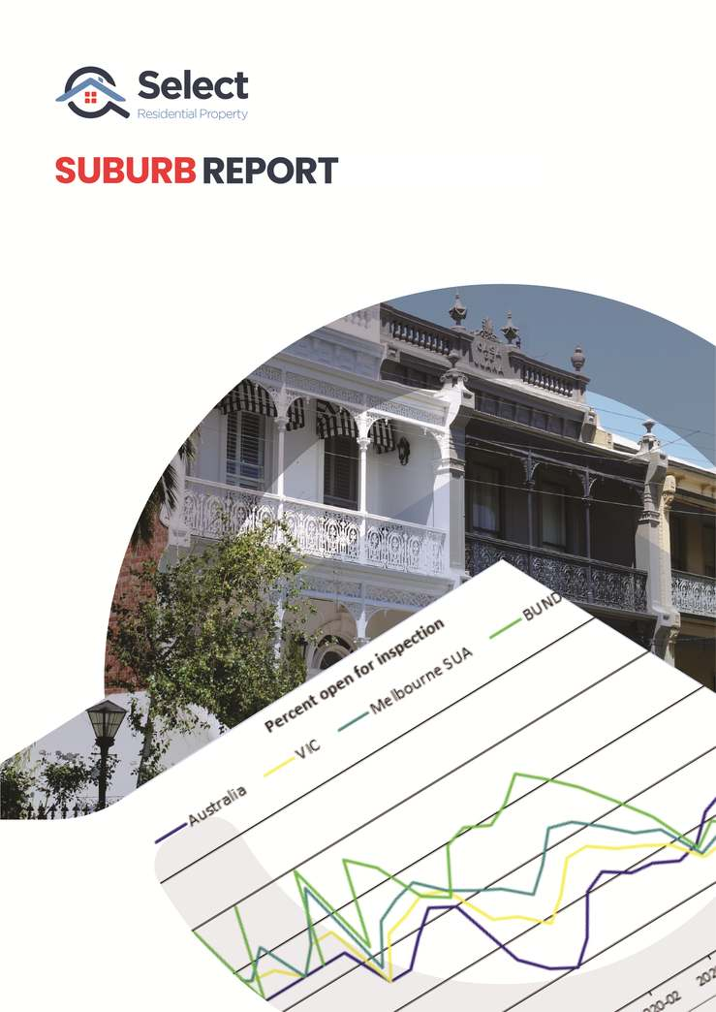
NORTH MELBOURNE VIC 3051 Houses

Suburb Report for NORTH MELBOURNE VIC 3051 Houses for 31 October 2021
Contents
Introduction
Demographics
Suburb Report basis
Demand to Supply Ratio+ (DSR+)
Demand to Supply Ratio (DSR)
Statistical reliability+ (SR+)
Statistical reliability (SR)
Typical value (TV)
Days on market (DOM)
Avg vendor discount (DISCOUNT)
Auction clearance rate (ACR)
Percent renters in market (RENTERS)
Vacancy rate (VACANCY)
Gross rental yield (YIELD)
Percent stock on market (SOM%)
Online search interest (OSI)
Market cycle timing (MCT)
Neighbour price balancing (NPB)
Ripple effect potential (REP)
Unit to house value (U2H)
Long term growth (LTG)
Percentage rent growth (PRG)
Percentage sales growth (PSG)
Percent sales by auction (SBA%)
Percent open for inspection (OFI%)
Statistics Summary
Strengths and Weaknesses
Growth forecast
More resources
Report Disclaimer

Introduction
This Suburb Report provides a great profile overview and demographic snapshot, which will help you obtain a clearer picture of the suburb and the community which lives within it.
Building on this data, and what is even more important in this report is how we investigate and present the level of interest in terms of current property buying and selling activity, as measured by the Select’s Demand and Supply Ratio (DSR).
Our DSR analysis will help you better understand what competitive tension you might experience when trying to buy either a house or unit within this market. It is also highly valuable in terms of assessing the potential for short term price movements that may occur when there is an imbalance between demand and supply.
We believe this report, and the data and insights contained within it, will provides you with a greater understanding and improved knowledge to help you make a more informed buying decision, when you combine it with other research and market assessment evaluation you need to conduct as part of your important due diligence process. Suburb Profile
North Melbourne is an inner suburb of Melbourne, Australia, 2 km north-west of Melbourne's Central Business District. Its local government area is the City of Melbourne. At the 2016 Census, North Melbourne had a population of 14,940.
North Melbourne is bounded by the CityLink freeway to the west, Victoria Street to the south, O'Connell and Peel Streets to the east and Flemington Road to the north. Since July 2008 its local government area has been the City of Melbourne, when it took over the administration of parts of Kensington and North Melbourne that were previously under the City of Moonee Valley, resulting in an increase of approximately 4760 residents and almost 3000 workers (2006 Census).
Formerly known as Hotham, it was essentially a working class area, with some middle class pockets, and was one of the first towns in Victoria to be granted Municipal status.
Today it continues to undergo gentrification, noted for its Victorian architecture, cosmopolitan demographic, commercial and older industrial areas.

Demographics
Key demographics stats according to ABS Census 2016:

Suburb Report basis
Prices move in response to the changes of supply and demand. For prices to rise, demand must exceed supply. The greater the degree by which demand exceeds supply the greater the pressure on prices to rise.
There can be a large number of factors influencing the tug-o-war between supply and demand. Some changes that might increase demand include:
- New roads
- Extensions to railway lines
- New bridges
- New hospitals or extensions to existing ones
- Private enterprises setting up in an area or government departments relocating
- New schools
- Changes in what people find appealing now days
Some changes that might lead to increases in supply include:
- Releases of new land or house and land estates
- Developers replacing low density properties with higher density ones
The degree to which these fundamental forces influence demand and supply can be measured using a set of key statistics. This report gathers and examines those key statistics. It measures the degree of balance between the forces of demand and supply in the NORTH MELBOURNE residential property market - specifically, Houses as they were at the end of 31 October 2021.
Note that this report only researches the statistics of supply and demand. The report does not detail circumstances concerning the drivers influencing these statistics. The research of those circumstances falls under the banner of "fundamental" research.
Terminology
“Property market” – we often use the term “market” instead of “suburb” when referring to a specific property type within the suburb i.e. houses or units. Houses in a suburb represent one property market while units in the same suburb are another market.
“SUA” – means Significant Urban Area. SUAs are defined by the Australian Bureau of Statistics. They are usually cities e.g. Sydney, Adelaide or Townsville. But sometimes they can refer to an area such as: “Newcastle – Maitland”, “Gold Coast – Tweed Heads” or “Canberra – Queanbeyan”.

Demand to Supply Ratio+ (DSR+)
A score out of 100 for the ratio of demand to supply in a property market that combines many supply and demand metrics. Read more about this metric.
The DSR+ for NORTH MELBOURNE Houses for the month ending 31 October 2021 was 66.
The minimum DSR+ for the country as at 31 October 2021 was 23 while the maximum was 85. The median DSR+ for the same period was 59 and the average was 58. This can be visualised in the Context Ruler Infographic which follows.
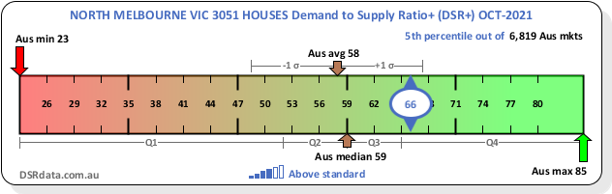
The following chart shows the recent history of changes in the DSR+.

Note that gaps may appear in the history where data was unavailable for those months.

Demand to Supply Ratio (DSR)
A score out of 100 for the ratio of demand to supply in a property market that combines a number of supply and demand metrics. Read more about this metric.
The DSR for NORTH MELBOURNE Houses for the month ending 31 October 2021 was 51. This is “Balanced”.
This market is in balance with respect to supply and demand. There is a healthy count of properties for sale compared to the number of interested buyers. There is a closely fought tug-o-war between buyers and sellers. Sellers may get away with a good price if they find a poorly researched buyer. Buyers may get a good price if they find a seller who wants a quick sale. Prices should grow in line with the national average.
The minimum DSR for the country as at 31 October 2021 was 28 while the maximum was 88. The median DSR for the same period was 66 and the average was 65. This can be visualised in the Context Ruler Infographic which follows.
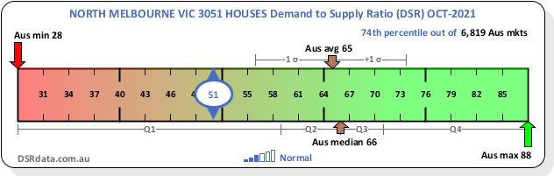
The following chart shows the recent history of changes in the DSR.

Note that gaps may appear in the history where data was unavailable for those months.

Statistical reliability+ (SR+)
A score out of 100 for the statistical reliability of the DSR+ for a property market. Read more about this metric.
The SR+ for NORTH MELBOURNE Houses for the month ending 31 October 2021 was 81.
The minimum SR+ for the country as at 31 October 2021 was 14 while the maximum was 85. The median SR+ for the same period was 66 and the average was 61. This can be visualised in the Context Ruler Infographic which follows.
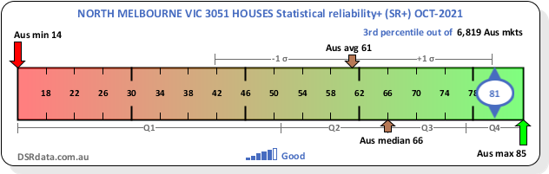
The following chart shows the recent history of changes in the SR+.

Note that gaps may appear in the history where data was unavailable for those months.

Statistical reliability (SR)
A score out of 100 for the statistical reliability of the DSR for a property market. Read more about this metric.
The SR for NORTH MELBOURNE Houses for the month ending 31 October 2021 was 80.
The minimum SR for the country as at 31 October 2021 was 26 while the maximum was 84. The median SR for the same period was 57 and the average was 56. This can be visualised in the Context Ruler Infographic which follows.
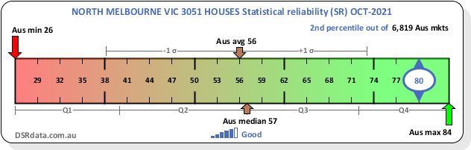
The following chart shows the recent history of changes in the SR.

Note that gaps may appear in the history where data was unavailable for those months.

Typical value (TV)
An estimate of the typical value of properties in a market. Read more about this metric.
The TV for NORTH MELBOURNE Houses for the month ending 31 October 2021 was $1,321,700.
The minimum TV for the country as at 31 October 2021 was $93,900 while the maximum was $12,236,809. The median TV for the same period was $613,879 and the average was $776,066. This can be visualised in the Context Ruler Infographic which follows.
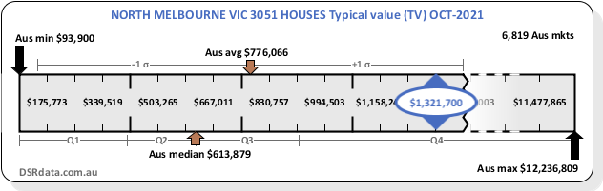
The following chart shows the recent history of changes in the TV.

Note that gaps may appear in the history where data was unavailable for those months.

The following table shows the total growth for these markets over a number of historical timeframes.
Name | Total growth last N years %
 | 1 | 2 | 3 | 5 | 10 | 20 | 30
NORTH MELBOURNE Houses | 11.44 | 3.28 | 9.37 | 13.1 | 66.29 | 286.46 | 811.52
Melbourne SUA | 12.63 | 20.15 | 18.59 | 32.9 | 61.67 | 264.14 | 564.88
Australia | 20.23 | 25.45 | 16.88 | 15.18 | 27.78 | 213.97 | 366.51

The next table shows these same markets and timeframes but with the growth converted to compound per annum.
Name | Compound growth per annum last N years %
 | 1 | 2 | 3 | 5 | 10 | 20 | 30
NORTH MELBOURNE Houses | 11.44 | 1.63 | 3.03 | 2.49 | 5.22 | 6.99 | 7.64
Melbourne SUA | 12.63 | 9.61 | 5.85 | 5.85 | 4.92 | 6.68 | 6.52
Australia | 20.23 | 12.01 | 5.34 | 2.87 | 2.48 | 5.89 | 5.27

Days on market (DOM)
The count of the number of days a property is listed for sale before eventually selling. Read more about this metric.
The DOM for NORTH MELBOURNE Houses for the month ending 31 October 2021 was 52 days.
The minimum DOM for the country as at 31 October 2021 was 1 days while the maximum was 999 days. The median DOM for the same period was 48 days and the average was 73 days. This can be visualised in the Context Ruler Infographic which follows.
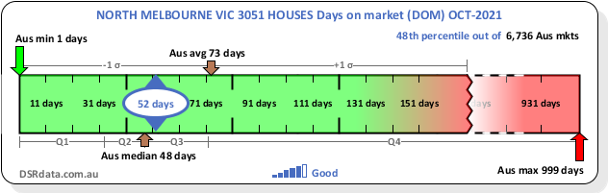
The following chart shows the recent history of changes in the DOM.

Note that gaps may appear in the history where data was unavailable for those months.

Avg vendor discount (DISCOUNT)
The % difference between the original asking price and the eventual sale price. Read more about this metric.
The DISCOUNT for NORTH MELBOURNE Houses for the month ending 31 October 2021 was 4.69%.
The minimum DISCOUNT for the country as at 31 October 2021 was -3.25% while the maximum was 21.75%. The median DISCOUNT for the same period was 2.51% and the average was 2.67%. This can be visualised in the Context Ruler Infographic which follows.
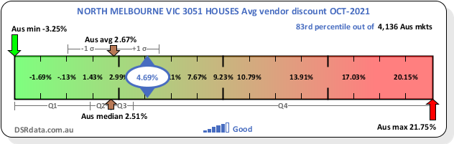
The following chart shows the recent history of changes in the DISCOUNT.

Note that gaps may appear in the history where data was unavailable for those months.

Auction clearance rate (ACR)
The % of properties for sale by auction that actually sell during the auction. Read more about this metric.
The ACR for NORTH MELBOURNE Houses for the month ending 31 October 2021 was 85.7%.
The minimum ACR for the country as at 31 October 2021 was 0% while the maximum was 100%. The median ACR for the same period was 100% and the average was 91.29%. This can be visualised in the Context Ruler Infographic which follows.
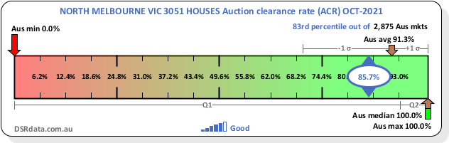
The following chart shows the recent history of changes in the ACR.

Note that gaps may appear in the history where data was unavailable for those months.

Percent renters in market (RENTERS)
The % of renters in the market as opposed to owner-occupiers and all other resident types. Read more about this metric.
The RENTERS for NORTH MELBOURNE Houses for the month ending 31 October 2021 was 70.3%.
The minimum RENTERS for the country as at 31 October 2021 was 0% while the maximum was 100%. The median RENTERS for the same period was 28.3% and the average was 30.27%. This can be visualised in the Context Ruler Infographic which follows.
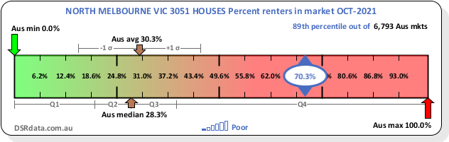
The following chart shows the recent history of changes in the RENTERS.

Note that gaps may appear in the history where data was unavailable for those months.

Vacancy rate (VACANCY)
The % of rental properties currently unoccupied. Read more about this metric.
The VACANCY for NORTH MELBOURNE Houses for the month ending 31 October 2021 was 2.3%.
The minimum VACANCY for the country as at 31 October 2021 was 0% while the maximum was 25%. The median VACANCY for the same period was 0.66% and the average was 1.23%. This can be visualised in the Context Ruler Infographic which follows.
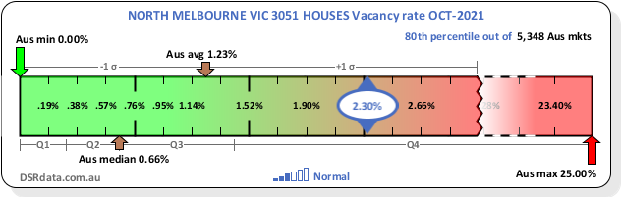
The following chart shows the recent history of changes in the VACANCY.

Note that gaps may appear in the history where data was unavailable for those months.

Gross rental yield (YIELD)
The typical rental incomes (annual gross) as a percentage of typical property values. Read more about this metric.
The YIELD for NORTH MELBOURNE Houses for the month ending 31 October 2021 was 2.53%.
The minimum YIELD for the country as at 31 October 2021 was 0.98% while the maximum was 9.98%. The median YIELD for the same period was 4.2% and the average was 4.37%. This can be visualised in the Context Ruler Infographic which follows.
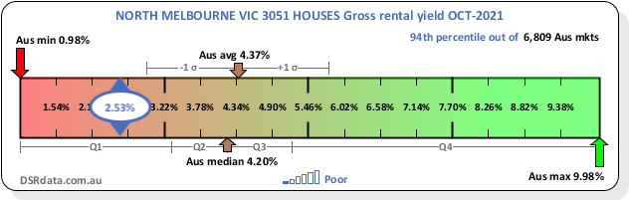
The following chart shows the recent history of changes in the YIELD.

Note that gaps may appear in the history where data was unavailable for those months.

Percent stock on market (SOM%)
The % of stock in a property market that is currently listed for sale. Read more about this metric.
The SOM% for NORTH MELBOURNE Houses for the month ending 31 October 2021 was 1.5%.
The minimum SOM% for the country as at 31 October 2021 was 0% while the maximum was 490%. The median SOM% for the same period was 0.92% and the average was 1.46%. This can be visualised in the Context Ruler Infographic which follows.
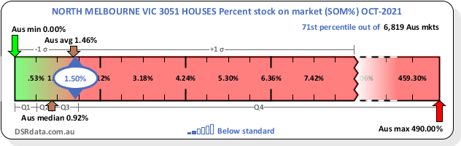
The following chart shows the recent history of changes in the SOM%.

Note that gaps may appear in the history where data was unavailable for those months.

Online search interest (OSI)
The ratio of people searching online for properties versus the number of properties available online. Read more about this metric.
The OSI for NORTH MELBOURNE Houses for the month ending 31 October 2021 was 461.
The minimum OSI for the country as at 31 October 2021 was 0 while the maximum was 9,122. The median OSI for the same period was 886 and the average was 1,160. This can be visualised in the Context Ruler Infographic which follows.
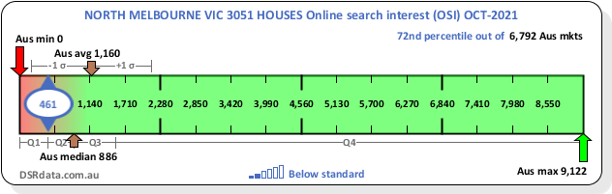
The following chart shows the recent history of changes in the OSI.

Note that gaps may appear in the history where data was unavailable for those months. Note that in late 2019 there was a change to the method used to calculate the OSI.

Market cycle timing (MCT)
A score out of 100 for the likelihood of a property market being at the start of its next surge in price growth. Read more about this metric.
The MCT for NORTH MELBOURNE Houses for the month ending 31 October 2021 was 76.
The minimum MCT for the country as at 31 October 2021 was 0 while the maximum was 94. The median MCT for the same period was 41 and the average was 42. This can be visualised in the Context Ruler Infographic which follows.
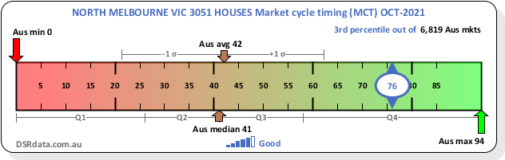
The following chart shows the recent history of changes in the MCT.

Note that gaps may appear in the history where data was unavailable for those months.

Neighbour price balancing (NPB)
The difference in typical value per km between the property market and its closest neighbours as a weighted average of distance. Read more about this metric.
The NPB for NORTH MELBOURNE Houses for the month ending 31 October 2021 was 74,496$/km.
The minimum NPB for the country as at 31 October 2021 was -250,000$/km while the maximum was 500,000$/km. The median NPB for the same period was 6,530$/km and the average was 4,186$/km. This can be visualised in the Context Ruler Infographic which follows.
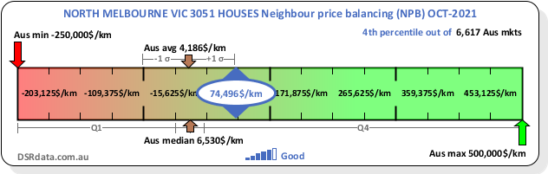
The following chart shows the recent history of changes in the NPB.

Note that gaps may appear in the history where data was unavailable for those months.

Ripple effect potential (REP)
The recent growth of neighbouring markets minus that of the target market indicating potential for growth to ripple.. Read more about this metric.
The REP for NORTH MELBOURNE Houses for the month ending 31 October 2021 was 1.86%.
The minimum REP for the country as at 31 October 2021 was -23.05% while the maximum was 21.27%. The median REP for the same period was 0.75% and the average was 0.33%. This can be visualised in the Context Ruler Infographic which follows.
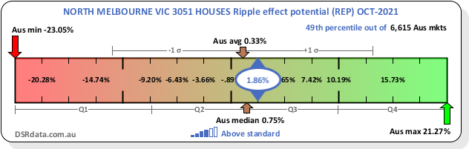
The following chart shows the recent history of changes in the REP.

Note that gaps may appear in the history where data was unavailable for those months.

Unit to house value (U2H)
A score out of 100 for the value of units compared to houses for a unit market or vice-versa for a housing market. Read more about this metric.
The U2H for NORTH MELBOURNE Houses for the month ending 31 October 2021 was 15.
The minimum U2H for the country as at 31 October 2021 was 0 while the maximum was 100. The median U2H for the same period was 39 and the average was 46. This can be visualised in the Context Ruler Infographic which follows.
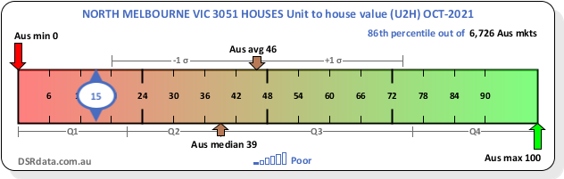
The following chart shows the recent history of changes in the U2H.

Note that gaps may appear in the history where data was unavailable for those months.

Long term growth (LTG)
The % growth per annum for the last 10 years. Read more about this metric.
The LTG for NORTH MELBOURNE Houses for the month ending 31 October 2021 was 4.65%.
The minimum LTG for the country as at 31 October 2021 was -10.84% while the maximum was 16.16%. The median LTG for the same period was 4.33% and the average was 4.01%. This can be visualised in the Context Ruler Infographic which follows.
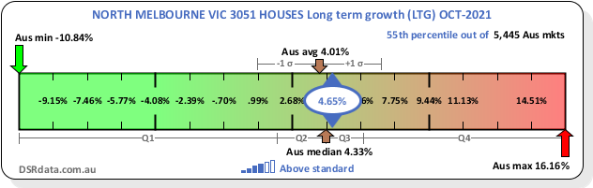
The following chart shows the recent history of changes in the LTG.

Note that gaps may appear in the history where data was unavailable for those months.

Percentage rent growth (PRG)
The % of growth in typical rents over the last 12 months. Read more about this metric.
The PRG for NORTH MELBOURNE Houses for the month ending 31 October 2021 was 7.35%.
The minimum PRG for the country as at 31 October 2021 was -52.67% while the maximum was 48.75%. The median PRG for the same period was 8.43% and the average was 9.39%. This can be visualised in the Context Ruler Infographic which follows.
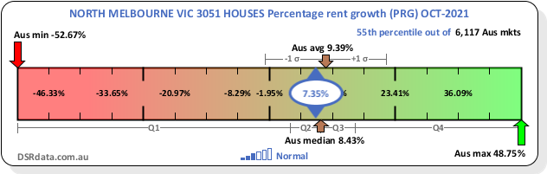
The following chart shows the recent history of changes in the PRG.

Note that gaps may appear in the history where data was unavailable for those months.

Percentage sales growth (PSG)
The % of growth in sales volume over the last 12 months. Read more about this metric.
The PSG for NORTH MELBOURNE Houses for the month ending 31 October 2021 was 9%.
The minimum PSG for the country as at 31 October 2021 was -50% while the maximum was 100%. The median PSG for the same period was -13.7% and the average was -9.46%. This can be visualised in the Context Ruler Infographic which follows.
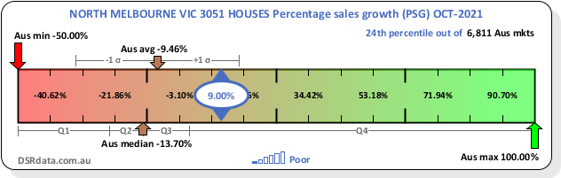
The following chart shows the recent history of changes in the PSG.

Note that gaps may appear in the history where data was unavailable for those months.

Percent sales by auction (SBA%)
The % of properties listed for sale by auction as opposed to those listed for sale by other means. Read more about this metric.
The SBA% for NORTH MELBOURNE Houses for the month ending 31 October 2021 was 54.5%.
The minimum SBA% for the country as at 31 October 2021 was 0% while the maximum was 100%. The median SBA% for the same period was 5.6% and the average was 22.58%. This can be visualised in the Context Ruler Infographic which follows.
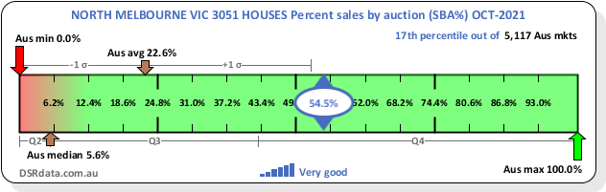
The following chart shows the recent history of changes in the SBA%.

Note that gaps may appear in the history where data was unavailable for those months.

Percent open for inspection (OFI%)
The % of properties listed for sale with open inspection dates as opposed to those viewed by appointment only or other means. Read more about this metric.
The OFI% for NORTH MELBOURNE Houses for the month ending 31 October 2021 was 20.6%.
The minimum OFI% for the country as at 31 October 2021 was 0.5% while the maximum was 100%. The median OFI% for the same period was 33.3% and the average was 39.38%. This can be visualised in the Context Ruler Infographic which follows.
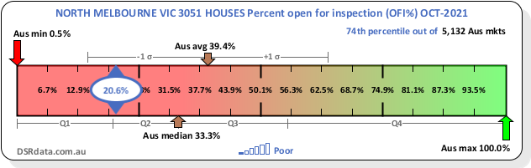
The following chart shows the recent history of changes in the OFI%.

Note that gaps may appear in the history where data was unavailable for those months.

Statistics Summary
The previously mentioned statistics are summarised in the following table:
Statistic | Value
Demand to Supply Ratio+ (DSR+) | 66
Demand to Supply Ratio (DSR) | 51
Statistical reliability+ (SR+) | 81
Statistical reliability (SR) | 80
Typical value (TV) | $1,321,700
Days on market (DOM) | 52 days
Avg vendor discount (DISCOUNT) | 4.69%
Auction clearance rate (ACR) | 85.7%
Percent renters in market (RENTERS) | 70.3%
Vacancy rate (VACANCY) | 2.3%
Gross rental yield (YIELD) | 2.53%
Percent stock on market (SOM%) | 1.5%
Online search interest (OSI) | 461
Market cycle timing (MCT) | 76
Neighbour price balancing (NPB) | 74,496$/km
Ripple effect potential (REP) | 1.86%
Unit to house value (U2H) | 15
Long term growth (LTG) | 4.65%
Percentage rent growth (PRG) | 7.35%
Percentage sales growth (PSG) | 9%
Percent sales by auction (SBA%) | 54.5%
Percent open for inspection (OFI%) | 20.6%

All data is for NORTH MELBOURNE VIC 3051 Houses for the month ending 31 October 2021.
This data will change from month to month as the market dynamics move around.

Strengths and Weaknesses
The following chart highlights the strengths and weaknesses of NORTH MELBOURNE VIC 3051 Houses with respect to each of the metrics. Each metric is scaled to a score out of 100 so they can all be compared fairly.

A good market is represented by a large polygon. The vertices close to the outside edge of the chart highlight the market’s strengths. Whereas a weakness is seen by a vertex close to the centre of the circle.
Please note that if there was no data available for a metric, an average will be used instead.

Growth forecast

The bar chart shows the forecasts over 1...5 years for the market under examination and its local government area; significant urban area (if applicable); and the nation as a whole. These forecasts are based on the Demand to Supply Ratio (DSR+). The DSR+ is in turn based on the other metrics you've already seen in this report. We've witnessed the growth of hundreds of thousands of property markets with all sorts of DSR+ scores. We've been calculating such scores Australia-wide since 2010. Now we can estimate how a market will grow if it has a specific DSR+.

The growth forecast chart shows the predicted path of growth. The realistic path appears in the middle of the band. The upper edge of the band is the optimistic growth forecast. The lower confidence bound is the pessimistic forecast.
We have a relatively high level of confidence that the property market will experience growth over the coming years somewhere within this band. However, there are no guarantees.

Year-month | Growth % |  |  | Forecasted value ($)
 | Pessimistic | Realistic | Optimistic | Pessimistic | Realistic | Optimistic
2022-10 | 6.3% | 8.3% | 10.2% | $1,405,000 | $1,431,000 | $1,457,000
2023-10 | 12.0% | 15.9% | 19.9% | $1,480,000 | $1,532,000 | $1,585,000
2024-10 | 17.6% | 23.5% | 29.5% | $1,554,000 | $1,633,000 | $1,711,000
2025-10 | 24.2% | 32.1% | 40.0% | $1,641,000 | $1,746,000 | $1,851,000
2026-10 | 30.6% | 40.5% | 50.5% | $1,727,000 | $1,858,000 | $1,988,000

More resources
Services offered by Select Residential Property:
- DSRdata.com.au - Our advanced research app for the astute researcher whereby you can access and assess thousands of property markets across Australia
- Sell or Hold – Helps determine if you should hold or sell a property asset, and all the important considerations in doing so
- Location Score – Our ‘keep it simple’ research app for the everyday person wishing to learn more about different opportunities multiple markets across Australia
- Suburb Growth – Know the value of property within a suburb today, isn’t as important as knowing what the value of property is forecast to do over the next 1, 2 or 3 years. This research tool can help with this question.
- Other SRP Reports – We have a range of other research reports for your consideration. You can check them out here
- If you need any more help or have any other requirements in the property research or data space, you can contact us at support@srponline.com.au

Report Disclaimer
This report does not constitute property, financial or investment advice. When it comes to selecting a suburb, a property within that suburb and assessing and negotiating on price, you need to consider many more factors and variables before making any such purchasing decision. We recommend you undertake further extensive due diligence before you act. As such you cannot rely on this report to make any such property buying or investment property purchase decision.
We recommend you seek professional advice from a licensed and/or qualified professional in their respective fields of knowledge, before making any financial or investment decision.
Select Residential Property does not warrant or make any representations in relation to this report and is not responsible or liable for any loss or damage you or any third party may suffer or incur in connection with this report or for any acts, omissions, errors or defaults of any supplier or third party in connection with this report.

